**Model Development Phase Template**

|  |  |
| --- | --- |
| **Date** | 11 July 2024 |
| **Team ID** | 740052 |
| **Project Title** | SmartLender - Applicant Credibility  Prediction for Loan Approval |
| **Maximum Marks** | 4 Marks |

**Initial Model Training Code, Model Validation and Evaluation Report**

The initial model training code will be showcased in the future through a screenshot. The model validation and evaluation report will include classification reports, accuracy, and confusion matrices for multiple models, presented through respective screenshots.

**Initial Model Training code:**

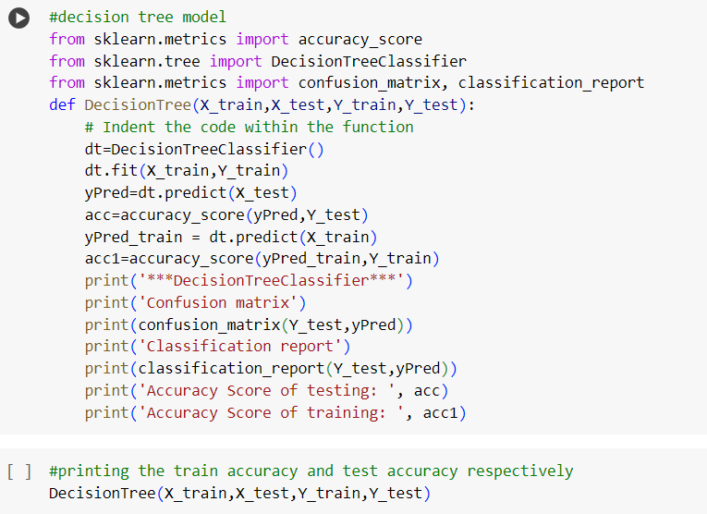

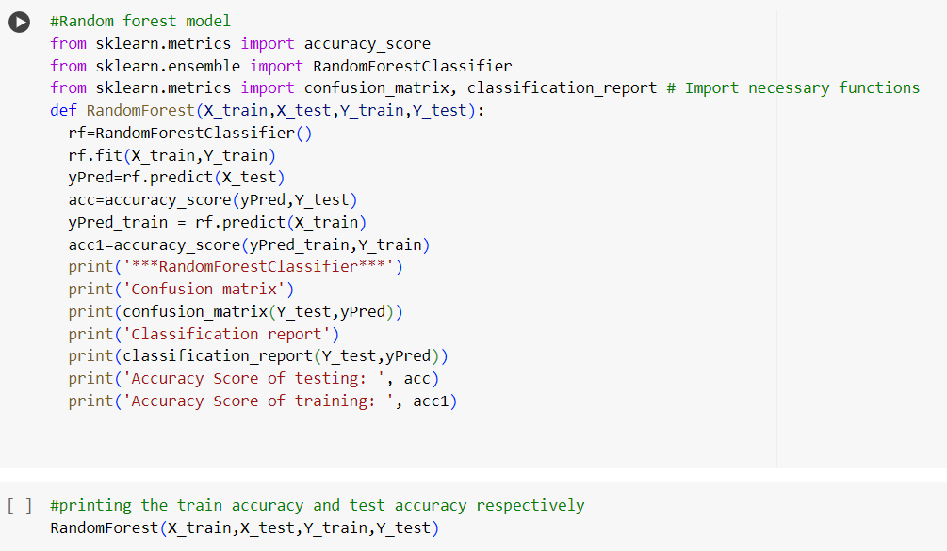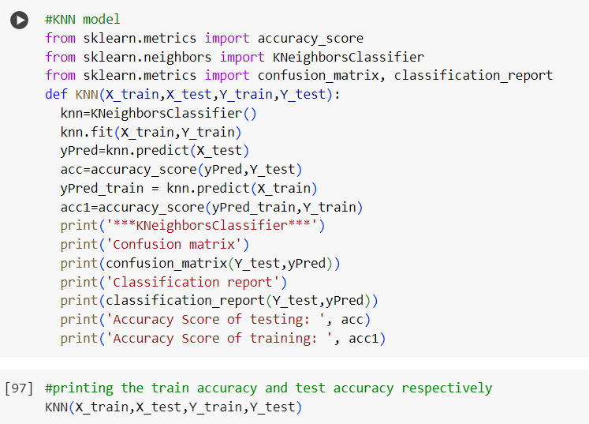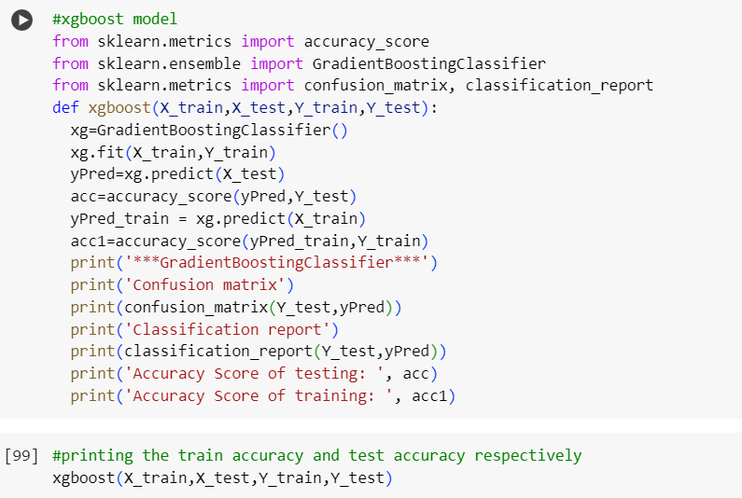

|  |  |  |  |
| --- | --- | --- | --- |
| **Model** | **Classification Report** | **F1**  **Scor e** | **Confusion Matrix** |
| Decision Tree |  | 67% |  |

**Model Validation and Evaluation Report:**

|  |  |  |  |
| --- | --- | --- | --- |
| Random Forest |  | 75% |  |
| KNN |  | 66% |  |
| Gradient  Boosting |  | 70% |  |